**Name : Khan Mohd Aaquib Sameer**

**Roll-no: 22CO21**

**Class : TE**

**Batch : B2**

**Topic: Case Study on RJ45 and CAT6 cable.**

***1. Introduction and Technical Specifications***

**Introduction**:

**RJ45 Connectors** :

The RJ45 connector is a standard type of physical connector for network cables. It looks like a large telephone plug and is commonly used in Ethernet networking. Introduced in the 1980s, RJ45 connectors have become essential in both home and business networking setups.

**Cat6 Cables:**

Category 6 (Cat6) cables are a type of twisted pair cable standard used for Ethernet and other network physical layers. Cat6 cables were introduced in the early 2000s and offer improved performance over their predecessors like Cat5 and Cat5e cables. They support higher data transfer speeds and bandwidth, making them suitable for more demanding applications.

**Specifications :**

**-RJ45 Connector** : 8 pins, used for Ethernet networking.

-**Cat6 Cable** : Supports frequencies up to 250 MHz, can handle speeds up to 10 Gbps over short distances (up to 55 meters).

Comparison with Other Cables :

Cat6 cables are an upgrade from Cat5 and Cat5e cables, offering better performance. While Cat5e supports up to 1 Gbps, Cat6 can handle up to 10 Gbps, albeit with a shorter effective range.

***2. Construction, Design, and Performance***

**Construction and Materials :**

- RJ45 Connectors: Made from plastic with metal contacts. The design includes a clip that ensures a secure connection.

- Cat6 Cables : Comprised of four twisted pairs of copper wires. The twisting reduces crosstalk and electromagnetic interference.

**Performance :**

**RJ45** connectors are designed for high-performance networking, facilitating reliable and efficient data transmission in Ethernet networks. They support speeds up to 10 Gbps when used with compatible cables like Cat6 or Cat6a, making them suitable for various applications ranging from home networking to enterprise environments. Their design minimizes signal loss and interference, ensuring stable and consistent connections. By securely connecting twisted pair cables, RJ45 connectors play a crucial role in maintaining the integrity and speed of network communications.

**Cat6** cables can handle higher data transmission speeds and bandwidth compared to older cables. They are designed to reduce crosstalk and electromagnetic interference, leading to more reliable and faster data transmission.

**Limitations :**

**RJ45** connectors support speeds up to 10 Gbps but may not handle higher speeds. They work effectively up to 100 meters, with signal degradation beyond this range. The plastic clip is fragile and can break easily. They are susceptible to interference in high electromagnetic environments and require precise installation to avoid connection issues. While backward compatible with older cables, their performance is limited by the lower category cable.

While Cat6 cables offer higher speeds, their maximum effective length for 10 Gbps speed is limited to 55 meters. Beyond this length, performance degrades, and the speed drops to 1 Gbps.

***3. Graphical Representation of RJ45 and CAT6***

1. Graphical Representation of RJ45 :-

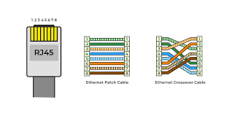

1. Graphical representation of CAT6 :-

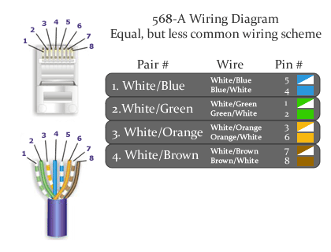

***4. Applications and Installation***

**Common Applications :**

Cat6 cables are used in various settings:

- Residential : Home networking, connecting devices like computers, gaming consoles, and smart TVs.

- Commercial : Office networking, connecting workstations, printers, and other networked devices.

**Installation Best Practices :**

- RJ45 Connectors : Ensure proper crimping to avoid poor connections. Use a cable tester to verify connections.

- Cat6 Cables : Avoid sharp bends and kinks. Maintain proper spacing from power cables to reduce interference.

Troubleshooting Tips :

- Check for loose connections.

- Use a cable tester to identify faulty cables.

- Ensure cables are not damaged or excessively bent.

***5. Standards, Compatibility, and Market Perspectives***

**Standards :**

Cat6 cables conform to the ANSI/TIA-568-C.2 standard for structured cabling. RJ45 connectors follow the ANSI/TIA-568 standard for network cabling.

**Compatibility :**

Cat6 cables and RJ45 connectors are backward compatible with older standards like Cat5 and Cat5e. This means you can use Cat6 cables with equipment designed for Cat5e, though the performance will be limited to the capability of the older equipment.

**Market Trends :**

The demand for Cat6 cables has grown with the increase in data-heavy applications and the need for faster internet speeds. They are widely available and have become more affordable over time.

**Cost Analysis** :

While Cat6 cables are more expensive than Cat5 and Cat5e, their improved performance and future-proofing capabilities make them a worthwhile investment, especially in environments requiring high-speed data transmission.

***6. Advancements, Future Trends, and Commercial Use***

**Technological Advancements :**

Newer cable standards like Cat6a, Cat7, and Cat8 offer even higher performance, with Cat6a supporting up to 10 Gbps over 100 meters. These advancements provide more options for high-speed networking.

**Future Trends :**

With the continuous growth of data consumption and the advent of technologies like 5G and the Internet of Things (IoT), the demand for high-performance networking cables will keep rising. Future cables will likely offer even higher speeds and better interference protection.

**Commercial Use :**

An office building installed Cat6 cables during renovation. This upgrade improved overall network performance, supporting their needs for video conferencing, large file transfers, and other data-intensive applications.

***7. Conclusion***

In conclusion, RJ45 connectors and Cat6 cables are fundamental components of modern networking, offering robust and high-speed connections suitable for a wide range of applications. Understanding their specifications, construction, performance, and practical use cases helps in making informed decisions for networking needs.